**Solution Architecture Specification**

| **Project Name** | … |
| --- | --- |
| **Customer** | … |
| **Last Saved Date** | … |
| **Revision** | … |

| Name | Organizational Position | Action | Date Reviewed |
| --- | --- | --- | --- |
| <approver> | < e.g. VP, IT Operations, Customer Name> | Approval |  |
| <reviewer> | <Other staff, Customer Name> | Reviewer |  |
| <reviewer> | <Other staff at Amristar> | Reviewer |  |
| <author> | Architect, Amristar | Author |  |

**Change History:**

| **Revision Date** | **Last Revision By** | **Reason for Change** |
| --- | --- | --- |
|  |  |  |
|  |  |  |
|  |  |  |
|  |  |  |

**Related Project Documents:**

|  |
| --- |
|  |
|  |
|  |
|  |

**Glossary**

Term Definition of term

**TABLE OF CONTENTS**

**1.** **BUSINESS REQUIREMENTS AND GOALS 5**

1.1. Business Drivers 5

1.2. Solution Requirements 5

1.3. High Level Metrics for Success 5

1.4. Architecture Boundary 5

**2.** **BUSINESS MODEL 6**

2.1. Organisational Context 6

2.2. Current Situation 6

2.3. Solution Definition 6

2.4. Actors 6

2.5. Interactions of Actors 6

2.6. Use Cases 7

**3.** **SOLUTION ARCHITECTURE MODEL 10**

3.1. Solution Components 10

3.2. Integration Specification 10

3.3. Walk-Throughs 11

3.4. Information Model 12

**4.** **DETAILED PHYSICAL ARCHITECTURE 14**

4.1. Network Diagram 14

4.2. System Specification Summary 14

4.3. Configuration Requirements 14

**5.** **SOLUTION IMPACT 15**

5.1. Impact on Processes 15

5.2. Impact on People 15

5.3. Technical Impact 15

**6.** **QUALITY ATTRIBUTES 16**

6.1. Reliability 16

6.2. Availability 16

6.3. Serviceability 16

6.4. Best Practice Commentary 16

6.5. Architecture Commentary 16

**7.** **SUCCESS CRITERIA AND TEST PLAN 17**

7.1. Use Case Validation 17

7.2. Validation of Solution metrics 18

7.3. Test Plan 19

**8.** **PHASING, ROADMAP, AND IMPLEMENTATION PLAN 20**

8.1. Technical Assumptions 20

8.2. Solution Phases and Technical Milestones 20

8.3. Technical Work BreakDown Structure 20

8.4. Implementation Instructions 20

**9.** **APPENDIX – TEST PLANS 21**

# **Business Requirements and Goals**

## **Business Drivers**

What is the motivation for doing this? Which problem exists that needs solving, or which opportunity exists?

## **Solution Requirements**

High-level description of what the solution should accomplish

## **High Level Metrics for Success**

How will you know whether you have succeeded? Provide tangible measurable targets that should be met in order for your solution to be a success

## **Architecture Boundary**

What is in-scope, and what is not in-scope.

# **Business Model**

## **Organisational Context**

Provide a contextual diagram of the current situation, with a brief description

## **Current Situation**

Provide a more detailed description of the current processes, explaining what the pain points are or which opportunities exist. This section should ideally include a diagram that describes the current situation, with an accompanying description. This section should justify why something needs to be done.

Example diagram:

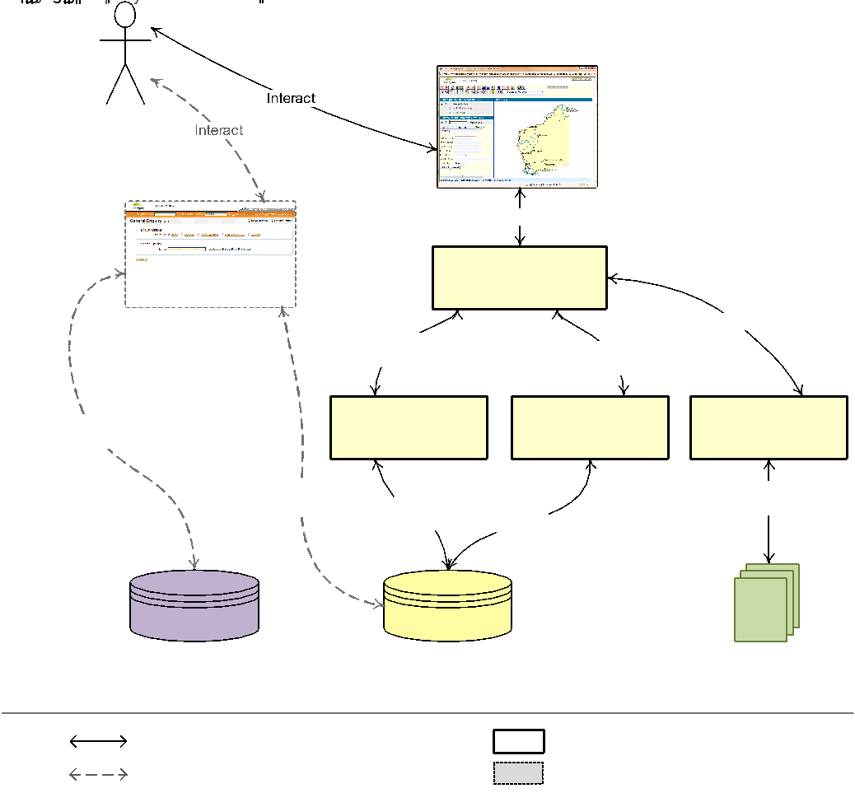

## **Solution Definition**

Provide a high-level non-technical description of the solution, its functions and capabilities, and how it addresses pain points or takes advantage of opportunities. This section should include a diagram, and a description of the diagram. This section should explain why/how your proposed solution fixes the issues raised earlier.

Example diagram:

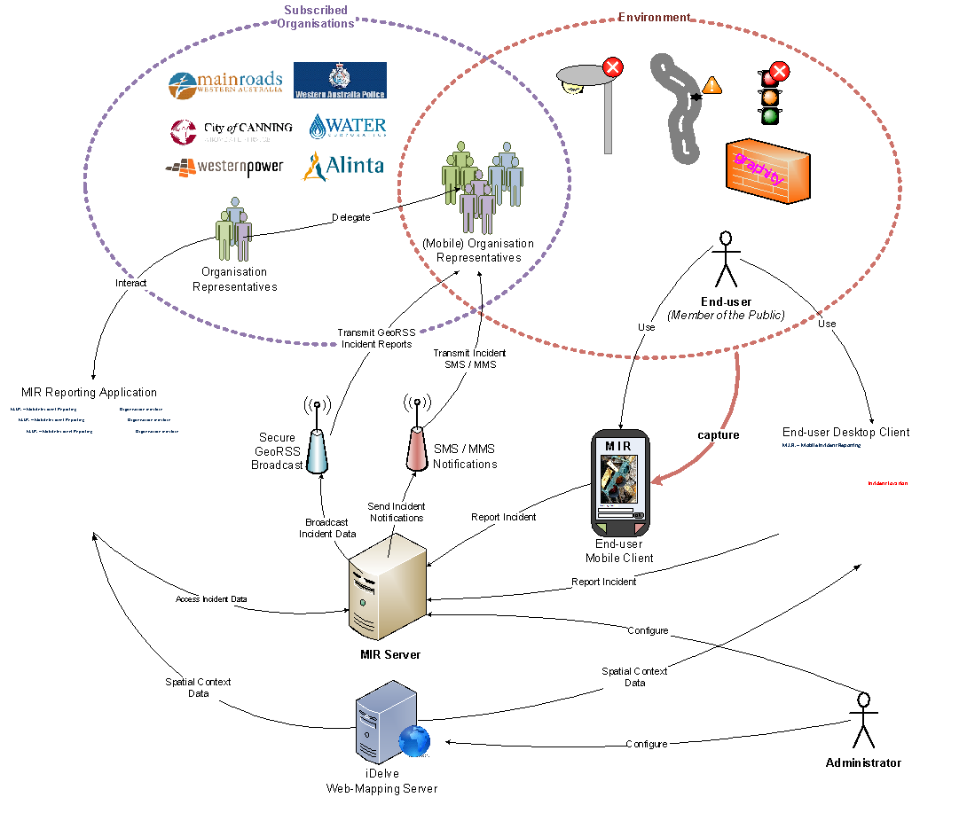

## **Actors**

Description of the actors of the new solution. These may be end-users, administrators, but could also include a scheduler (if it triggers action) and a different type of non-person actor.

| **Actor** | **Description** | **Current Use of the System** | **Expected Use of the New Solution** |
| --- | --- | --- | --- |
| < * Role - e.g. end-users, administrators> | < * Resp-onsibility and affiliation. e.g. UNIX sysadmins> | < * e.g. manual process via phone of fax> | < * e.g. automated process> |

## **Interactions of Actors**

This should describe which business functions are accessed by which actors (some may be accessed by both) and includes a diagram. Sample diagram shown below.



## **Use Cases**

This section describes the use cases supported by the solution. A typical solution has about 7 use cases. If you have more than about 9, it means your solution either would have to be broken up, or you are going into a level of detail that is unnecessary for being able to describe the architecture.

Each use case should have a UML process flow diagram (cross-functional “swimlane” diagram)

Template:

| **Goal** | Describe the goal, but from a “functional” perspective, not from a technical implementation perspective. |
| --- | --- |
| **Actor(s)** | List actors who conduct this use case |
| **Description** | Describe the use case step-by-step, including possible options and exceptions. It must be detailed enough for readers to grasp the use case. |
| **Frequency** | Describe when and how often this use case is triggered/actioned |
| **Pre-processing** | What must have happened first before this use case is able to take place. For example, user registration, data sourcing, etc. |
| **Post-processing** | What happens after this use case takes place, e.g. send email, call Web Service, post-process a dataset, validate, etc. |
| **Included use case** | Which generic use case is included in this, e.g. “view details” or “send email” |
| **Extended use case** | Which use case does this extend? For example, “print page” an extension of “process order”? |

Example:

| **Goal** | Process Incident Report | **Code** | MIR-04 |
| --- | --- | --- | --- |
| **Actor(s)** | Organisation Representative | | |
| **Description** | Organisation Representatives can perform several processing steps on an incident report:   * Delegate report – an incident report can be marked as delegated, to inform the user and the organisation that the incident is attended to. It can also be delegated to a different authority, if this is appropriate. * Export report(s) – organisations can export incident reports in delimited format for import into other business systems to manage incidents internally * Close resolved incident report – Organisation Representatives can mark an incident report as resolved, causing it to be closed and removed from the list of unresolved incidents * Save to dataset – when MIR is used as a data collection platform, an Organisation Representative can view inspect events before having them saved to a “master” dataset.   The Organisation Representatives must be presented with an error or warning if mandatory fields have not been filled out. | | |
| **Frequency** | As required. | | |
| **Pre-processing** | An incident report has been lodged by an End-user | | |
| **Post-processing** | Incident reports are marked as delegated, resolved, exported to a file, or saved to a master dataset | | |
| **Included use case** | MIR-04-1, MIR-04-2, MIR-04-3, MIR-04-4 | | |
| **Extended use case** | None | | |

| **Goal** | Perform Sales Property Search | **Code** | MV-02 |
| --- | --- | --- | --- |
| **Actor(s)** | Public User / Registered User | | |
| **Description** | The User performs a search for a property or location in the sales shutter. The matching locations are returned as links. If a user clicks on a matching location, the map extent changes to this location. No sales information is presented within the search result. | | |
| **Frequency** | As required. | | |
| **Pre-processing** | The Property Finder is launched, and the sales shutter is visible. | | |
| **Post-processing** | The matching results are returned to the user as links that lead to a location. | | |
| **Included use case** | None. | | |
| **Extended use case** | None. | | |

Example Diagram:



# **Solution Architecture Model**

This section describes the architecture of the solution.

## **Solution Components**

Describe the components which make up the architecture. They can be internal or external. This section should not describe them from a marketing perspective, but purely from a functional perspective in the context of the solution.

## **Integration Specification**

This section should show an integration diagram of the solution to-be. It shows how each component depends on other components. It should have commentary describing the diagram.

Example diagram:

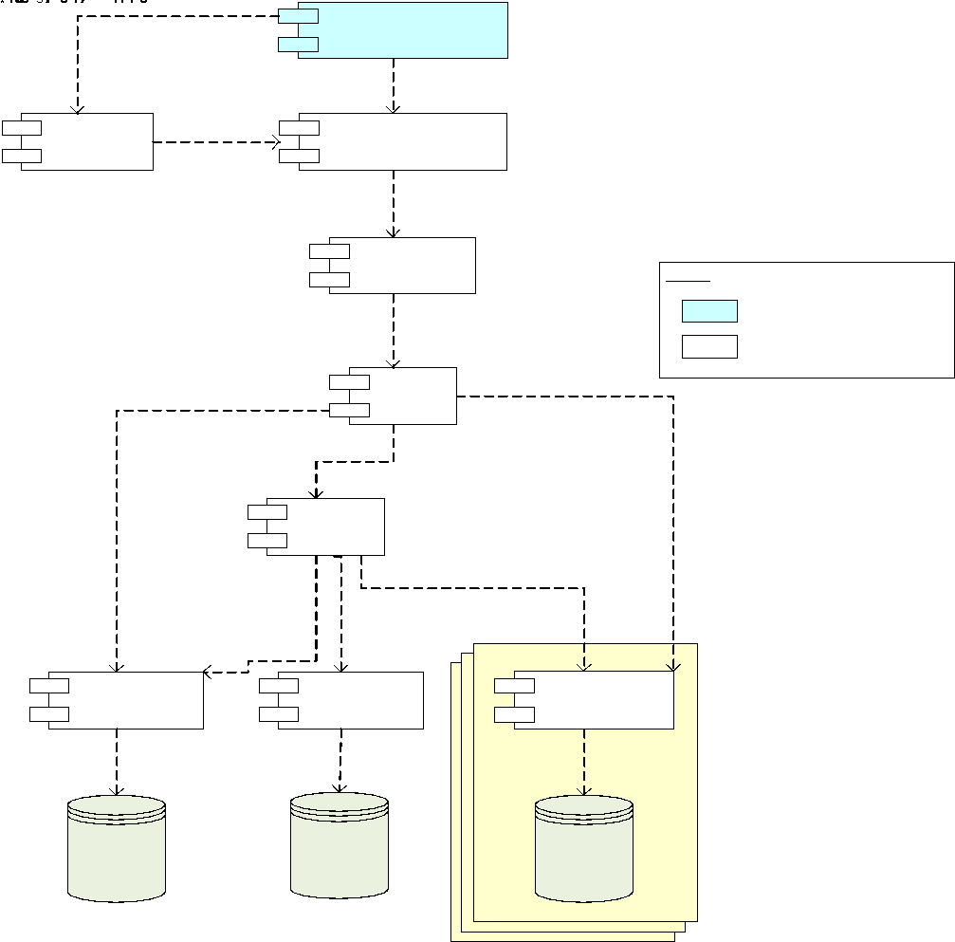

## **Walk-Throughs**

Provide a walkthrough for each use case, with “lanes” for each major component, and numbered arrows for each step. Snippets from diagrams or UI mockups can be included in this to help illustrate the link between the UI and back-end processes. The diagram should be preceded by a small description, and after the diagram there must be a detailed description for for each (numbered) step.

Example:

This activity involves the End-user viewing the status page of an incident report through a mobile or desktop browser, or an Organisation Representative viewing lodged incidents through the MIR Reporting Application.



Figure 22- View Incident Report

| **Step** | **Description** |
| --- | --- |
| 1. | The End-user accesses the Incident Viewer through a mobile or desktop browser, or the Organisation Representative accesses the MIR Reporting Application |
| 2. | The application is launched, ready for the End-user or Organisation Representative to request details of a particular incident. For the web-based status page, incident ID’s can be provided as GET variables in the URL. |
| 3. | After providing an incident number, or selecting an incident report from a list in the MIR Reporting Application, a request is sent to the MIR server for details on the incident, which are presented to the user |
| 4. | For the MIR Incident Reporting Application used by the Organisation Representative, a request is made to the iDelve server for mapping data. |
| 5. | Mapping data is obtained from the various data sources used by the iDelve server |
| 6. | Processed mapping data is sent back from the iDelve server to the MIR Incident Reporting application for display in the map |

## **Information Model**

This section has an ER-diagram and explanatory notes describing the entities and relationships. This section is only needed if the information model is sufficiently complex. In the case of 2 or 3 entities, it may not be needed.

Example:



# **Detailed Physical Architecture**

This section provides a detailed description of the physical architecture for each environment (DEV, UAT, PROD, etc.). It should include the physical servers and their specifications, and must allow the reader to see grouping of servers and geographic locations.

## **Network Diagram**

This section describes the locations of the various parts of the solution. It should cover the sites in scope of the solution, network connections, machines, routers, applications, DR site (where applicable). It should include port numbers, protocols, etc.   
This section should ideally include a diagram.

## **System Specification Summary**

This sections describes the specifications for each node in the previous section. A node may be a server, desktop, appliance, network device etc. The minimum disk space, memory and other sizing requirements should reflect the solution requirements.

| **Node** | **Product**  **Versions**  **Options** | **Platform**  **OS**  **SP level**  **Kernel version** | **Memory**  **CPU**  **Processor Speed**  **# NIC cards** | **Minimum Disk Space** | **Quantity required** Or indicate if an existing system is being used. |
| --- | --- | --- | --- | --- | --- |
|  |  |  |  |  |  |
|  |  |  |  |  |  |

## **Configuration Requirements**

This section describes specific configuration requirements, which could include ports, firewall rules, etc.

# **Solution Impact**

This section should describe the impact which the solution has on processes, people and existing technology.

## **Impact on Processes**

This section describes the impact on processes, including newly required processes, procedures, or changes to existing policies. It could include introduction of change control mechanisms or bodies, processes for dealing with incidents. Existing processes should be cited where applicable.

## **Impact on People**

This section should describe impacts on roles, including changes to existing roles or new roles introduced as a result of the solution. It should describe resource requirements, including how many people are needed for each part of the solution, and the training required.

## **Technical Impact**

This section describes the technical impact, which can include changes to the SOE, network infrastructure, server infrastructure, etc.

# **Quality Attributes**

This section covers the quality attributes applicable to the solution. Different quality attributes to the ones below may be applicable, depending on the nature of the solution.

## **Reliability**

This should discuss things like fault tolerance, fault avoidance, (dynamic/elastic) scalability in case of spikes, expected capacity vs. maximum capacity, and references to any process changes to support it.

## **Availability**

This covers things such as redundancy and disaster recover, as well as anticipated downtime in the event of catastrophic failure. It should cover measures in place to protect against malicious attacks, back-up strategies, etc. If new processes are introduced to support any of this, those should be referenced.

## **Serviceability**

This should cover how the solution can be supported (documentation and tools provided to help troubleshoot problems), options to extend or interface with the solution, how updates/upgrades are applied, maintenance processes, etc.

## **Best Practice Commentary**

This should note whether any deviations from proper practice exist as a result of specific technology or customer requirements or constraints.

## **Architecture Commentary**

This can discuss the potential of the solution to be adapted in future to changing business requirements or evolutions in technology.

# **Success Criteria and Test Plan**

This section describes how the solution is validated.

## **Use Case Validation**

This section describes how the use cases (covered earlier) can be tested. It should match the use cases covered earlier.

Example:

| **Use Case ID** | **Use Case Name** | **Validation** |
| --- | --- | --- |
| MV-01 | Preview Spatial Data | When the user selects a region of WA (e.g. South West) and category of spatial data (e.g. Natural Resources) the system displays a map with the corresponding extents and spatial layers.  The Public User can update the information displayed on the map by selecting and/or unselecting public spatial layers.  The user can modify the map view using zoom and pan operations.  The user can create a bookmark for the current map view, which stores a browser bookmark to retrieve the saved map context.  The users can view a saved map context by retrieving a previously created bookmark. |
| MV-02 | Perform Simple Analysis | The custom layer can also be downloaded as a GML document.  The user can display the distance between designated points on the map.  The user can display the longitude and latitude coordinates for designated point on the map.  The user can display the details for a specific map feature, or all features contains within a define bounding-box or circular radius.  The user can retrieve map features that match spatial attribute criteria.  The user can display location information for a designated spatial coordinate.  The user can create a PDF or GIF image of the current map view. |
| MV-03 | Add Spatial Data Layers | The user can include additional spatial layers sourced from an OGC Data Service or spatial database. |
| … | … | … |

## **Validation of Solution metrics**

This section describes how the solution metrics can be validated. The method of validation must be specific and reproducible. Example:

Example:

| Maximum plugin footprint size | 120 – 180k |
| --- | --- |
| Web application footprint size (total) | 150 – 200k |
| Application load time (first load) | 8 – 10 seconds |
| Application load time (subsequent loads, cached) | 4 – 6 seconds |
| Data refresh times | 1 – 3 seconds |

The above metrics must be met 95% of the time.

## **Test Plan**

Successful completion of the test plan is the basis for solution acceptance. Refer to the attached test plan template in the appendix, which must be filled out for each use case. It is a more detailed version of the use case validation, and should cover metric validation.

# **Phasing, Roadmap, and Implementation PLan**

This section describes how implementation is broken down, and includes phasing, a detailed work breakdown structure and implementation instructions.

## **Technical Assumptions**

This section describes the technical dependencies, which can include a suitable lab, servers with specific operating systems, appropriate network infrastructure, etc.

## **Solution Phases and Technical Milestones**

This section describes the phasing at a high level, and milestones (including deployments, UAT testing, go-live, etc.). It should not cover costs/effort. It should line up with any existing WBS or project plan.

## **Technical Work BreakDown Structure**

This section include a WBS, being a detailed list (with grouping) of all the activities required to deliver the solution. It is more detailed than the solution phasing, and should cover all aspects of development. You may reference or include a project plan, if one exists.

## **Implementation Instructions**

This section should include clarifying notes to accompany the WBS, for the purpose of assisting developers in delivering the solution. It should reference appropriate documentation where necessary. It should not cover details already covered elsewhere, but should focus on specifics and “gotchas” (whether from a technical or business perspective) which are unlikely to be known to developers.

# **Appendix – Test Plans**

|  | | **Date 18/05/2022** | **Test Title** | | Logging into Virtual Jukebox applicaion | | **Test Case No** | 1 | | | | **Ver** | 1.0 | |
| --- | --- | --- | --- | --- | --- | --- | --- | --- | --- | --- | --- | --- | --- | --- |
| **Tested By** | | | Dillon Matthias Vincent | | **Platform** | | **Browser** | | | **Connection** | | |
|  | |  | | |  | | |
| **Pass/Fail** | | | P | | **Severity (if Failed)** | | | | | **1-2-3-4** | | |
| **Comments** | | |  | | | | | | | | | |
| **STEP** | **ACTION** | | | **EXPECTED RESULT** | | **ACTUAL RESULT** | | | | **Pass/Fail** | **UA** | | | **Severity** |
|  | Describe the action to be taken | | | Describe the results expected | | Describe the actual results, if they are the same as expected state “As Expected” | | | | P/F | User Acceptance Ref | | | If “F” severity 1-4 |
|  | Open the Virtual Jukebox application | | | It brings the user to Login/Signup Page | | As Expected | | | | P |  | | |  |
|  | Click ‘Login’ button | | | It brings the user to the Login Page | | As Expected | | | | P |  | | |  |
|  | Enter Username and Password | | | The username field is filled and is visible to the user.  The password field is filled, but it in encrypted and not visible to the user. | | As Expected | | | | P |  | | |  |
|  | Click ‘Enter’’ | | | It brings the user to the Home Page | | As Expected | | | | P |  | | |  |
|  |  | | |  | |  | | | |  |  | | |  |
|  |  | | |  | |  | | | |  |  | | |  |
|  |  | | |  | |  | | | |  |  | | |  |
|  | **END OF TEST** | | | | | | | | | | | | | |